**Applied Machine Learning**

**Lab Report 1**

**Hafiz Ahmad**

**19l-1316**

**Section-8A**

**INTRODUCTION:**

This trial centers around finding out about circles, works, and exhibits in Python. Using distinct symbols, we investigate a variety of arrays, including lists, tuples, and dictionaries. Data can be altered based on requirements using lists enclosed in square brackets. While dictionaries contain keys and values, tuples are immutable and are enclosed in round brackets. While and for loops are also covered in the experiment.

**OBJECTIVES:**

The objective of this experiment is to utilize Google Collab for Python programming and develop proficiency in problem-solving using Python. The specific areas of focus include data types, loops, functions, and arrays.

**Procedure:**

The experiment requires Python knowledge of arrays, loops, functions, and data types. Capabilities empower code reuse and association, circles work with iterative execution, and clusters give productive information stockpiling and control. For a variety of applications, these components make it possible to develop code that is modular, effective, and adaptable.

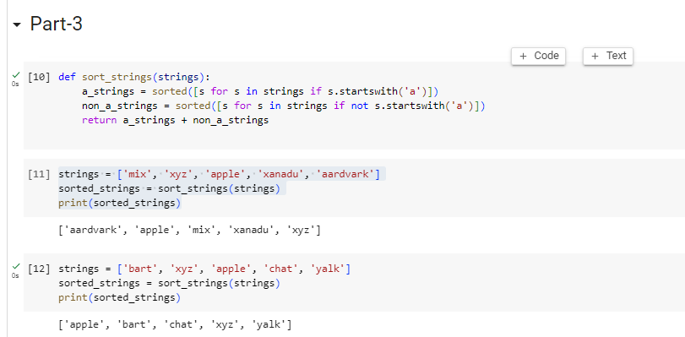

**Application:**

By doing this experiment In programming, functions are used to group a series of instructions that must be carried out repeatedly or are organized into their own sub-programs. Circles give a helpful method for staying away from manual contribution of individual qualities, while records are widely utilized. Data analysis, scientific computing, algorithmic problem-solving, simulation, and modeling are all areas where these programming elements can be used.

**Issues:**

No issue found while performing in the lab.

**Conclusion:**

In conclusion, this experiment gave a comprehensive understanding of functions, lists, tuples, and loops, as well as how they are used, which made it easier to understand and use them.

**Post lab:**

**Case-2:**

**Inserting different values in it**

